## **Build an ubuntu AMI using Packer**

* Create a repository in Azure

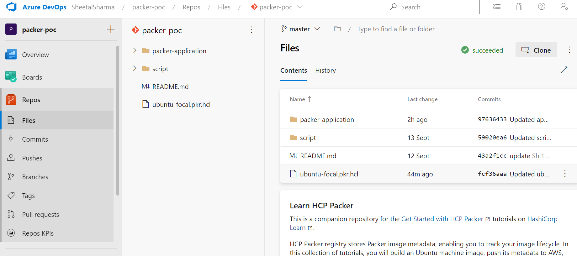

* Add the packer templates in that repo

## ubuntu.pkr.hcl

packer {

  required_plugins {

    amazon = {

      version = ">= 1.1.4"

      source  = "github.com/hashicorp/amazon"

    }

  }

}

variable "version" {

  type    = string

  default = "2.0.0"

}

data "amazon-ami" "ubuntu-focal-east" {

  region = "us-east-2"

  filters = {

    name = "ubuntu/images/hvm-ssd/ubuntu-focal-20.04-amd64-server-*"

  }

  most_recent = true

  owners      = ["099720109477"]

}

source "amazon-ebs" "basic-example-east" {

  region         = "us-east-2"

  source_ami     = data.amazon-ami.ubuntu-focal-east.id

  instance_type  = "t2.small"

  ssh_username   = "ubuntu"

  ssh_agent_auth = false

  ami_name       = "packer_AWS_{{timestamp}}_v${var.version}"

}

data "amazon-ami" "ubuntu-focal-west" {

  region = "us-west-1"

  filters = {

    name = "ubuntu/images/hvm-ssd/ubuntu-focal-20.04-amd64-server-*"

  }

  most_recent = true

  owners      = ["099720109477"]

}

source "amazon-ebs" "basic-example-west" {

  region         = "us-west-1"

  source_ami     = data.amazon-ami.ubuntu-focal-west.id

  instance_type  = "t2.small"

  ssh_username   = "ubuntu"

  ssh_agent_auth = false

  ami_name       = "packer_AWS_{{timestamp}}_v${var.version}"

}

build {

  hcp_packer_registry {

    bucket_name = "learn-packer-ubuntu"

    description = <<EOT

Some nice description about the image being published to HCP Packer Registry.

    EOT

    bucket_labels = {

      "owner"          = "platform-team"

      "os"             = "Ubuntu",

      "ubuntu-version" = "Focal 20.04",

    }

    build_labels = {

      "build-time"   = timestamp()

      "build-source" = basename(path.cwd)

    }

  }

  sources = [

    "source.amazon-ebs.basic-example-east",

    "source.amazon-ebs.basic-example-west"

  ]

}

* Launch an ubuntu instance
* And install the agent in that instance
* Goto project settings- Agent pool-New agent

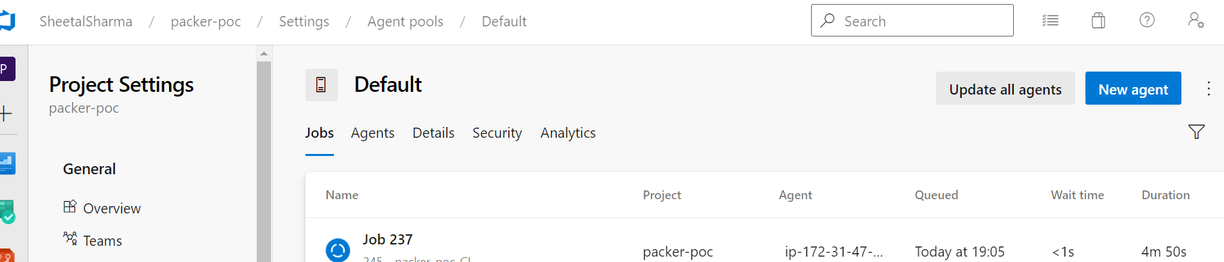

* Wget <https://vstsagentpackage.azureedge.net/agent/2.211.1/vsts-agent-linux-x64-2.211.1.tar.gz>
* mkdir myagent && cd myagent
* tar zxvf ~/Downloads/vsts-agent-linux-x64-2.211.1.tar.gz
* ./config.sh

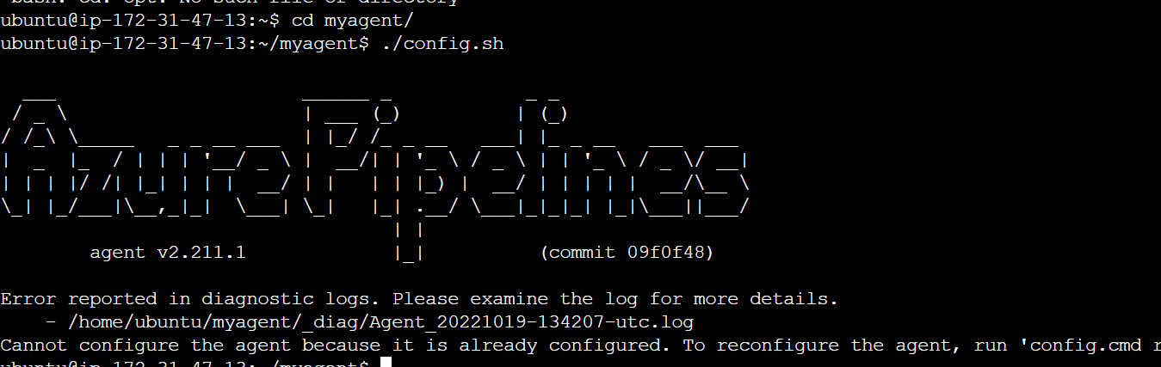

* ./run.sh
* Install AWS CLi in the instance
* Configure the Acess key and secret key
* To set environment variables Goto pipeline-library-variable group
* Add the variables

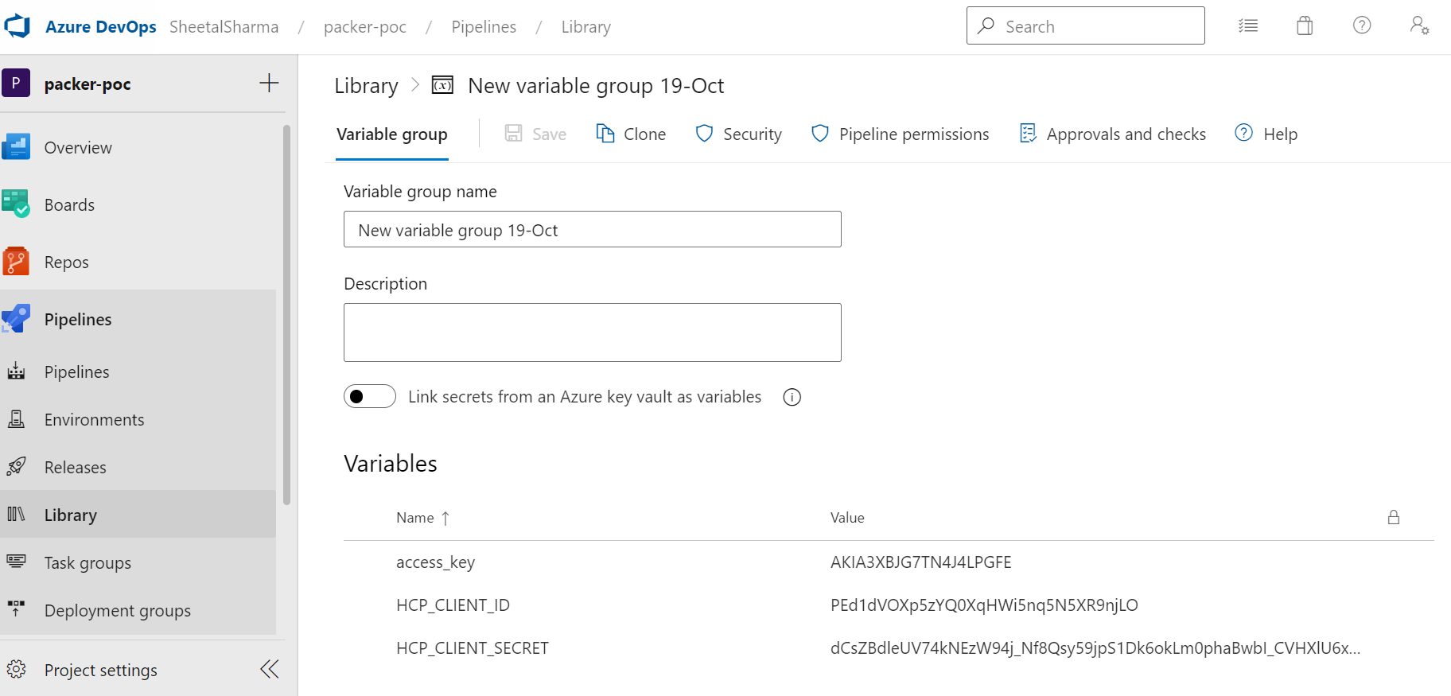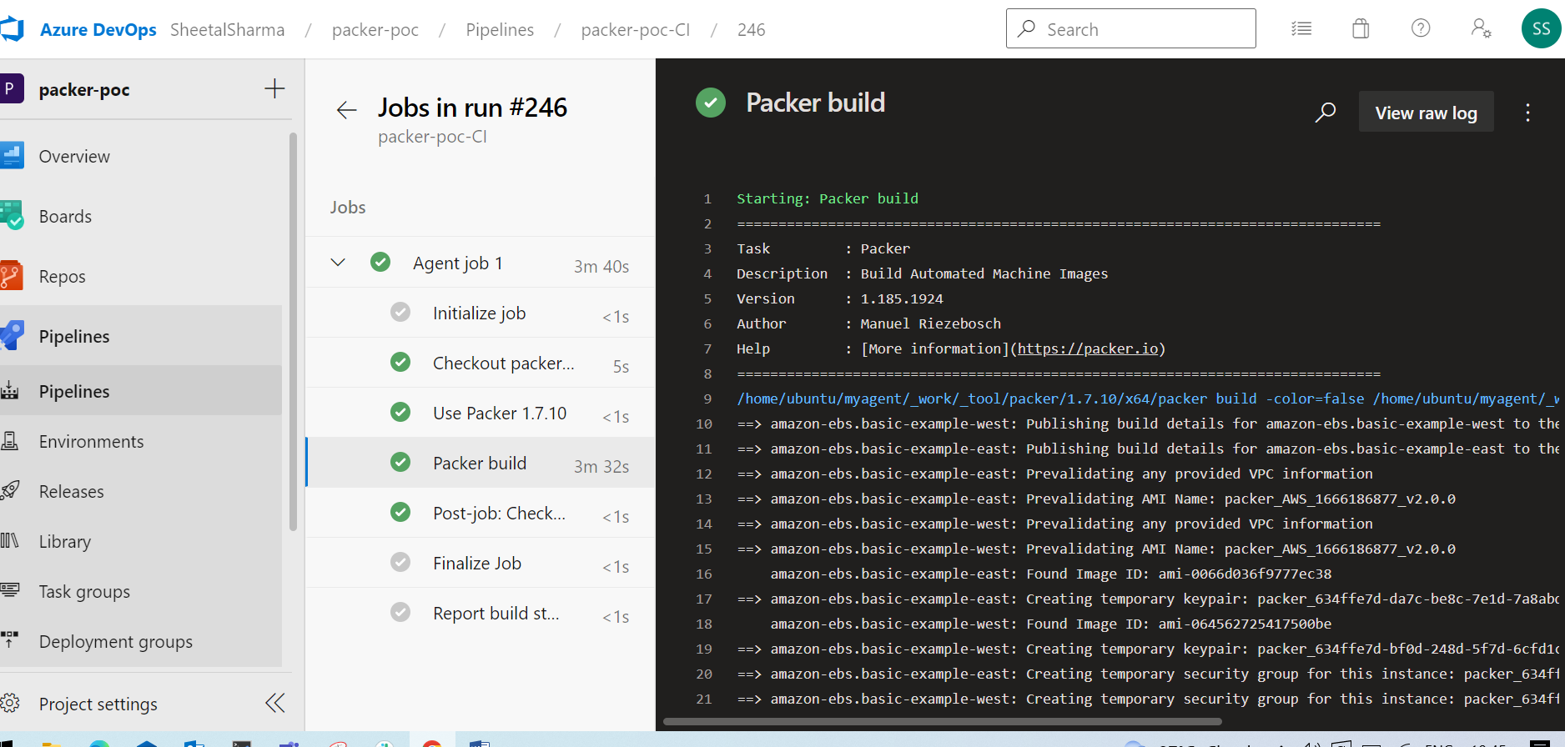

* After running the pipeline AMI is created in the AWS account which we have configured

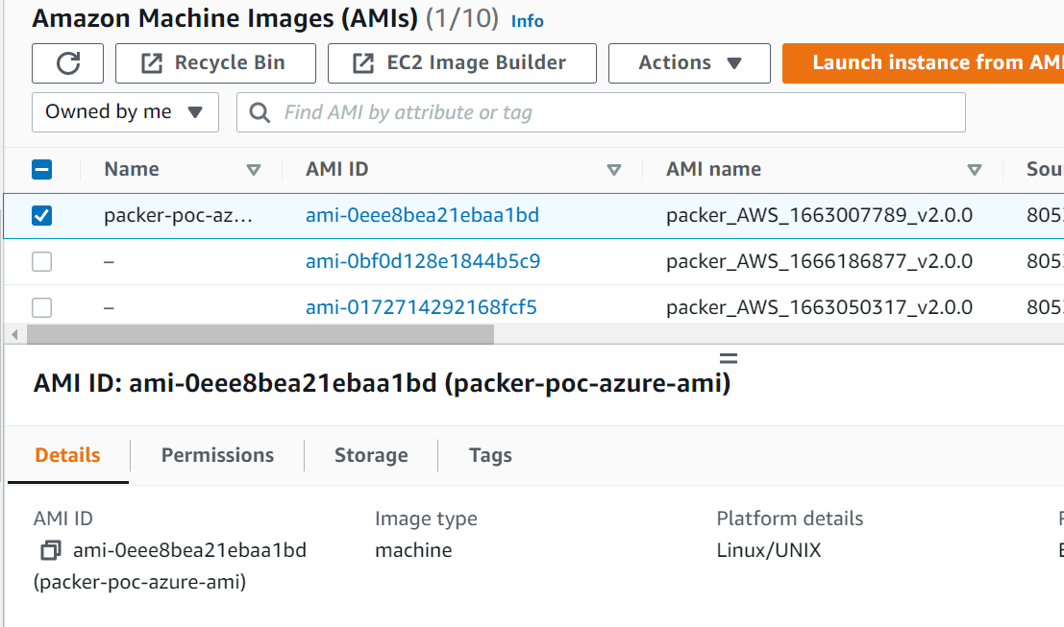

* To store the iterations in Hashicorp account we need application.pkr template

packer {

  required_plugins {

    amazon = {

      version = ">= 1.1.7"

      source  = "github.com/hashicorp/amazon"

    }

  }

}

data "hcp-packer-iteration" "ubuntu" {

  bucket_name = "learn-packer-ubuntu"

  channel     = "production"

}

data "hcp-packer-image" "ubuntu-east" {

  bucket_name    = "learn-packer-ubuntu"

  iteration_id   = data.hcp-packer-iteration.ubuntu.id

  cloud_provider = "aws"

  region         = "us-east-2"

}

data "hcp-packer-image" "ubuntu-west" {

  bucket_name    = "learn-packer-ubuntu"

  iteration_id   = data.hcp-packer-iteration.ubuntu.id

  cloud_provider = "aws"

  region         = "us-west-1"

}

source "amazon-ebs" "application-east" {

  ami_name = "packer_AWS_{{timestamp}}"

  region         = "us-east-2"

  source_ami     = data.hcp-packer-image.ubuntu-east.id

  instance_type  = "t2.small"

  ssh_username   = "ubuntu"

  ssh_agent_auth = false

  tags = {

    Name = "learn-packer-application"

  }

}

source "amazon-ebs" "application-west" {

  ami_name = "packer_AWS_{{timestamp}}"

  region         = "us-west-1"

  source_ami     = data.hcp-packer-image.ubuntu-west.id

  instance_type  = "t2.small"

  ssh_username   = "ubuntu"

  ssh_agent_auth = false

  tags = {

    Name = "learn-packer-application"

  }

}

build {

  hcp_packer_registry {

    bucket_name = "learn-packer-application"

    description = <<EOT

Some nice description about the image being published to HCP Packer Registry.

    EOT

    bucket_labels = {

      "foo-version" = "3.4.0",

      "foo"         = "bar",

    }

  }

  sources = [

    "source.amazon-ebs.application-east",

    "source.amazon-ebs.application-west"

  ]

}

